25th ANNUAL

ASH FLAT EAGLE FEST

ASH FLAT BALL PARK
140 NIX RIDGE RD/COLLEGE DR.

SEPTEMBER 7^{TH (Saturday)} 10 AM – 9PM
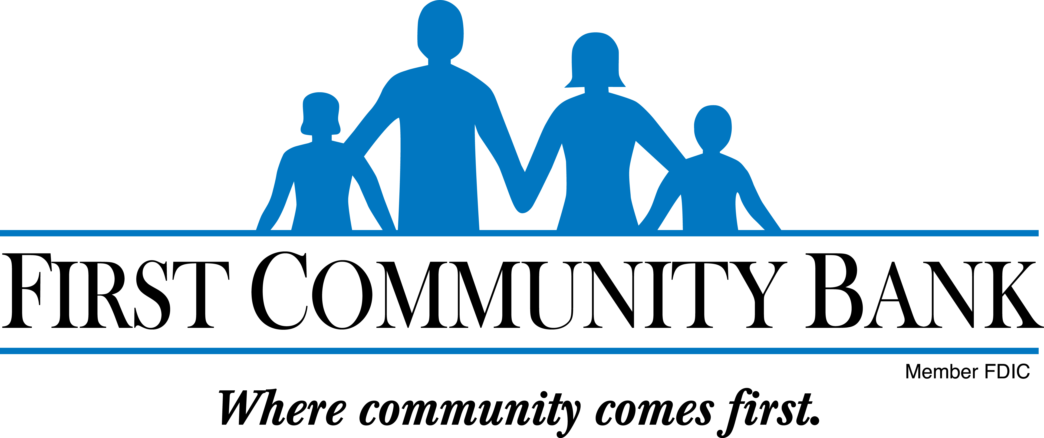
11:00 to 12:00 and 2:00 to 5:00
- Sponsored by
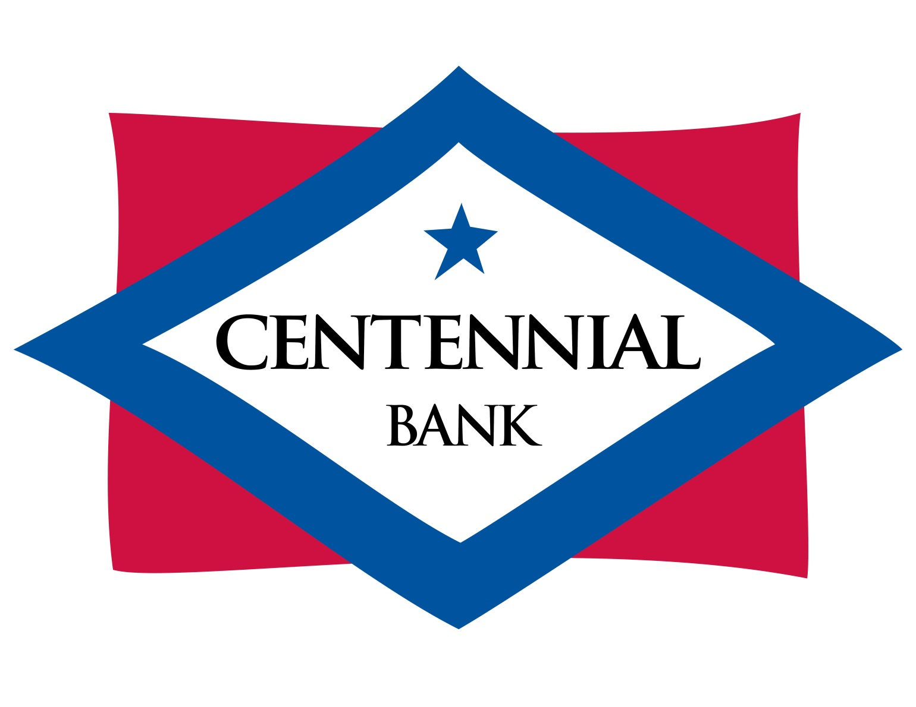
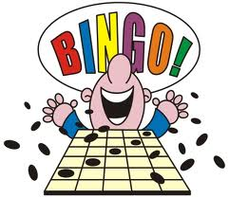
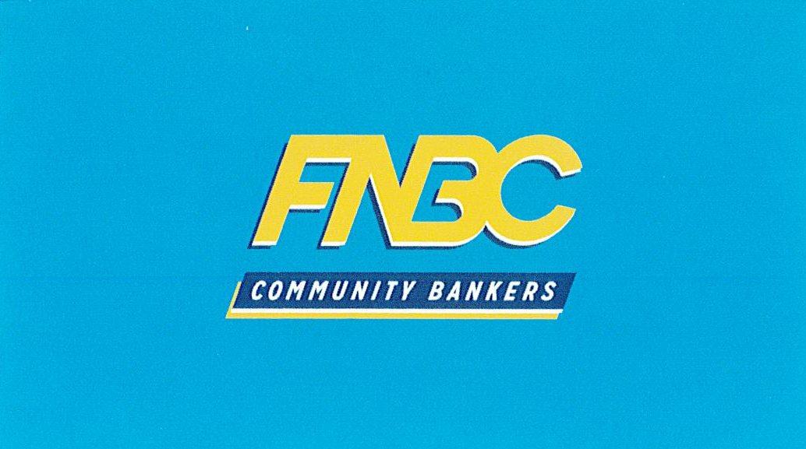
& local donors
Cash & Gift Prizes

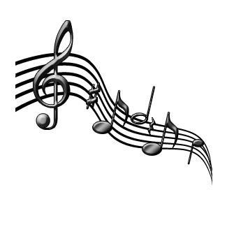
LIVE ENTERTAINMENT!


12:00 pm “Elvis” Butch Dicus
2:00 pm Mercy River Boys
5:00 pm Garrett Duncan & Dennis Horton
6:30–9:00 pm Forever Young (Street Dance)

Craft & Food Vendors

** Silent Auction **
Proceeds to be given to
local charitable organizations
DRAWINGS

Everyone be sure to stop at the Eagle Fest booth
for your chance
to enter the drawings

qqqqqqqq

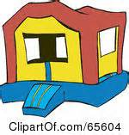

11:00 am To 8:00 pm
Inflatables for all ages!!

~~ Bounce House ~~ ~~ Zoo Playland ~~

~~Rock Climb Slide ~~ ~~Junior Sports ~~

Free raffle for children 18 and under Bikes & Other Toys
Drawings @ 6:00 pm Must be present to win

Bring your lawn chairs and enjoy the day!
For more information 870-994-7324 or Facebook page “Ash Flat Eagle Fest”

